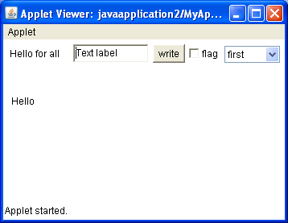
import java.applet.*;
import java.awt.*;
import java.awt.event.*;

public class MyApplet extends Applet implements MouseListener,
MouseMotionListener, ActionListener, ItemListener{
private Button fButton;
private TextField fTextField;
private Label fLabelForTextField;
private Choice theChoice;
private Checkbox fCheckBox;
String msg="Hello";
Image img;

public void init()
{
addMouseListener(this);
addMouseMotionListener(this);

add(new Label("Hello for all"));
fTextField= new TextField("Text label");
add(fTextField);
fLabelForTextField=new Label("Текст в текстовом поле");

img=getImage(getDocumentBase(),"picter.jpg");

fButton=new Button("write");
add(fButton);
fButton.addActionListener(this);

fCheckBox=new Checkbox("flag");
add (fCheckBox);
fCheckBox.addItemListener(this);

theChoice=new Choice();
theChoice.addItem("first");
theChoice.addItem("second");
add(theChoice);
theChoice.addItemListener(this);
}
public void paint(Graphics g)
{
//g.drawImage(img,20,120,100,100,this);

g.drawString(msg,10,80);
}
public void start(){
}
public void actionPerformed(ActionEvent ae) {
String str=ae.getActionCommand();
msg=fTextField.getText();
msg+=", список: "+theChoice.getSelectedItem();
if (fCheckBox.getState()) msg+=", ptichka est";

if (str.equals("write"))msg="нажали кнопку, текст:"+msg;

repaint();
}
public void mouseClicked(MouseEvent me){
String m;
showStatus("Clicked");
fTextField.setText("Clicked");
}

public void mousePressed(MouseEvent me) {
showStatus("pressed");
}

public void mouseReleased(MouseEvent me) {
}

public void mouseDragged(MouseEvent me) {
showStatus("Dragged");
}

public void mouseMoved(MouseEvent me) {
showStatus("Moved");
}

public void itemStateChanged(ItemEvent arg0) {
}

public void mouseEntered(MouseEvent arg0) {
}

public void mouseExited(MouseEvent arg0) {
}

}

